
Sreenidhi Institute of Science and Technology
Regulations:
A15
(An Autonomous Institution)
Code No: 5D301 Date:17-Nov-16
B. TECH. II-Year I-Semester Examinations, Nov/Dec 2016 (Regular)
DISCRETE STRUCTURES AND GRAPH THEORY (ECM)

Time: 3 Hours Max. Marks: 75

Note: No additional answer sheets will be provided.

Part - A
Max.Marks:25

Answer all QUESTIONS

- Write the truth table for (P↔Q)? [3M]
- Define the following a) Semi group b) sub group [3M]
- Define Recursive function. [3M]
- Define Universal Specification and Existential Specification. [3M]
- Show that the set “N” is a monoid with respect to multiplication. [3M]
- How many 5 letter words can be formed from the word ‘DADDY’? [2M]
a) 20 b)120 c) 15 d) 80
- Define the following terms: a)A complete graph b) Edge disjoint [2M]
- Construct truth table for the statement formula (P ∨∼Q) [2M]
- What is a Recurrence relation? [2M]
- Define planar graph. [2M]

Part – B
Max.Marks:50

ANSWER ANY FIVE QUESTIONS. EACH QUESTION CARRIES 10 MARKS.

- a) Show the following premises are inconsistent.
    - If Jack misses many classes through illness, then he fails high school.
    - If Jack fails high school, then he is uneducated.
    - If Jack reads lot of books, then he is not uneducated.
    - Jack misses many classes through illness and reads lot of books.

b) Show that W follows logically from the premises
∼T→∼R, ∼S, T → W, R ∨ S.

- a)Symbolize the following argument and check for its validity:
i) Every living thing is a plant or animal.
ii) David’s dog is alive and it is not a plant.
iii) All animals have Hearts. Hence, David’s dog has a heart.

b) Show that the negation of the sentence
(∀x) [{C(x) ∧ B(x)} →∼A(x)}] is
(∃x) {C(x) ∧ B(x) ∧ A(x)}

- a) Define partially ordered sets. Let X = {2, 3, 6, 12, 18, 36, 48, 56}, Define a relation “R” as follows; nRm means n divides m. Draw the Hasse diagram of (X ; R).

b) Show that set of all strings is a monoid under the operation ‘concatenation of strings’. Is it a Group? Justify your answer.

- a) Consider all six digit numbers not beginning with zero, how many numbers are there?

b) How many different license plates is there that involve 1, 2 or 3 letters followed by 4 digits.

- a) Solve the recurrence relation a_{n} = -6a_{n-1} – 9a_{n-2}, a₁ = 2.5, a₂ = 4.7.

b) Use the technique of backtracking, to find an explicit formula for the sequence defined by the recurrence relation and initial condition for
a_{n} = a _{n-1}+ n, a₁ = 4

- a) What is chromatic number? Give the chromatic number for the following graphs.
Mention the colors assigned to vertices also.

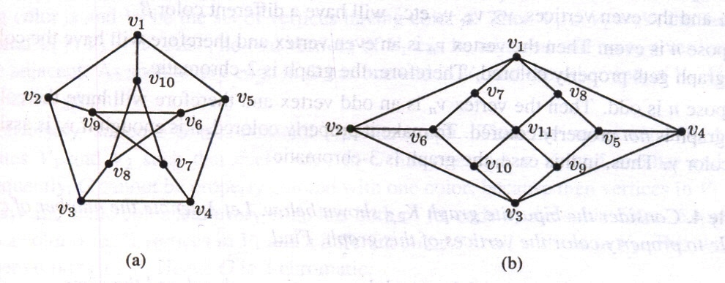

b) Explain Bipartite Graphs with example.

- a) Construct truth table for [(p∧q) ∨(∼r)] ↔ p

b) Show that (∼P ∧ (∼Q ∧ R)) ∨( Q∧ R ) ∨ (P ∧ R) ⇔ R

c) Obtain principal disjunctive and principal conjunctive normal for the following
  - (P ∧ Q) ∨(∼P ∧ R )
  - ∼(P∧Q)

- a) Discuss DFS algorithm with example.

b) Define Euler circuit and Hamilton path with example.

-- 00 -- 00 --

